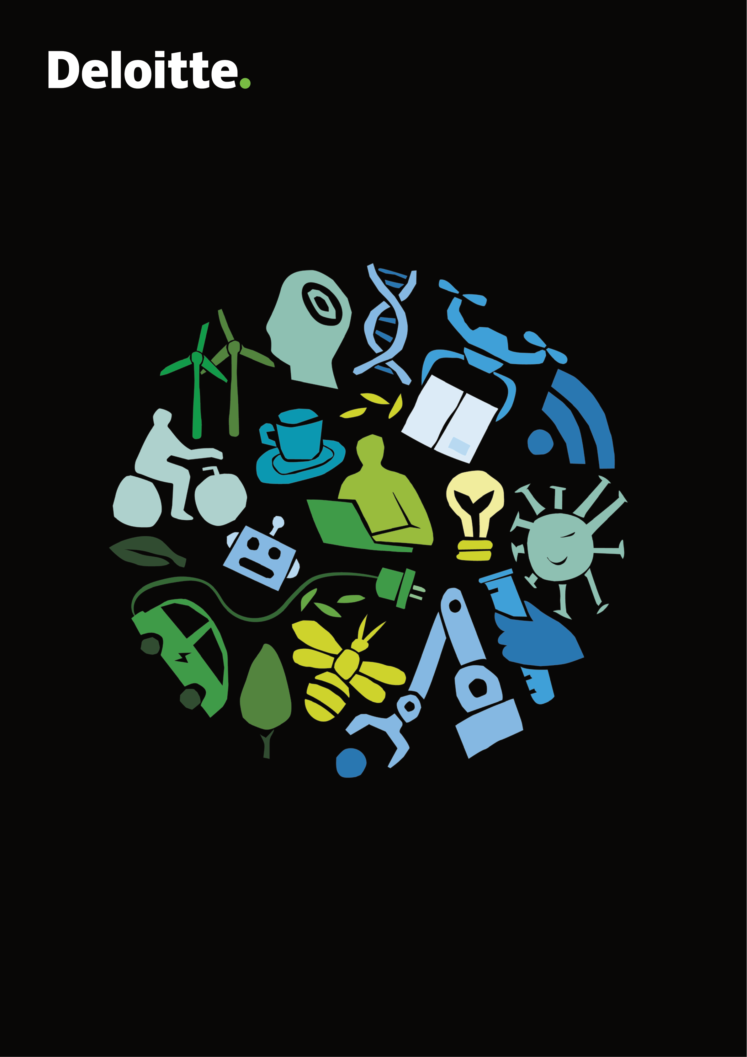

Annual report 2020/21

|  |  |
| --- | --- |
| Annual report 2020/21 **| Contents** | Annual report 2020/21 **| Contents** |

Contents

|  |  |
| --- | --- |
| CEO message  Business model and network  Strategy: FY23 Ambition - still connecting for impact  **People**  Making room for diversity of all kinds  Female Academy: Inspiring the female leaders of the future  Anne Sofie Kann Povelsen: A strong network will take you where you want to go  Jay Choi: Racism does exist – so we need to have those hard conversations | 4  6  6  **8**  8  12  14  16 |

Line Egelund Thuesen: Moving from communications to accounting   
– while leveraging both skillsets 18

**Performance**  **20**   
Audit & Assurance - On a journey towards business sustainability with

|  |  |  |  |
| --- | --- | --- | --- |
| 2 | people at the centre | 20 | 3 |
| Consulting - A team like no other | 22 |
| Risk Advisory - Turning risk into strategic advantages | 24 |
| Tax & Legal - Empowering our clients through transparency and compliance | 25 |
| Financial Advisory - Raising the bar for financial advisory services | 28 |
| **Planet & Transparency** | **30** |
| Fostering a more sustainable future | 30 |
| Sustainability in Deloitte | 34 |
| Small Great Nation’s Youth Panel – a vision for Denmark in 2040 | 36 |
| **Client Impact** | **38** |
| Making an impact for clients | 38 |
| Danish Agro – preventing hackers from damaging agriculture | 39 |
| F&H – kickstarting an e-commerce transformation | 40 |
| JOE & THE JUICE – supporting a global journey locally | 41 |
| The Danish Ministry of Health – collaborating on the COVID-19 vaccine rollout | 42 |
| Financial review | 43 |
| Statement by Management on the annual report | 44 |
| Financial Statements | 52 |

Annual report 2020/21 **| CEO message**  Annual report 2020/21 **| CEO message**

**CEO Message**

Building trust in a year

of uncertainty

|  |  |  |  |  |  |
| --- | --- | --- | --- | --- | --- |
|  | **T** have continued to reshape our business and helped our uncertainty, and we have focused on responding,  recovering and thriving post the pandemic. We his past year has seen unprecedented |  | “I am an optimist by nature, and after not just surviving | |  |
| but thriving in a year of unprecedented disruption, | |
| I have a great confidence in our team and the future | |
| clients reshape theirs by building resilient leadership, |
| of our business.” | |
| making businesses more agile and accelerating |
| innovation. As individuals, in teams and together with our |
| **Anders Dons,** CEO & Partner | |
| clients, we have embraced megatrends as opportunities |
| for growth rather than perceiving them as limitations. |
| Creating a diverse workplace is one of our most  important commitments. And we are progressing on diversity – particularly around women in leadership. In | |  | | --- | | **A couple of facts for the year:** | |
| Our purpose is to create an impact for our clients, our |
| people and the society we are part of. While our purpose |
| is not new, it feels more relevant than ever, because it |
| reminds us that we are here to help our colleagues and | Denmark and in Deloitte, we have had a strong objective | •After a year of responding, recovering and |
| clients build a sustainable business and society built | of getting more women at the top levels but progress in | thriving, we are finishing the year with 4 |
| on trust that we can pass on in a better state for future | the past few years has been slow. It takes time to build | percent growth and total revenue of DKK 3.7 |
| generations. Our aspiration is to be the #1 or #2 within | *Anders Dons, CEO & Partner* | up the female talent pipeline and to change the culture | billion. All business areas have a very positive |
| all the business areas we choose to play in. Our values | to include more diversity. Diversity is what our clients | outlook for the future. |
| are our guiding principles on how to create impact, be | continued to guide clients through this challenging | expect, and it is the only way to create competitive | |
| inclusive and take care of each other. In short, help build | solutions in the future. So, this year I am really proud | •Deloitte is still the strongest and most |
| trust between institutions and people. | situation, the financial aid packages and the special audit | that we are moving in the right direction with 40 per | valuable ‘commercial services’ brand globally |
| **Helping our clients into the future** | circumstances have implied. | cent of newly appointed partners being female as well | according to Brand Finance. |
| as a new female business leader and a female industry | |
| While our people and their wellbeing are the heart and | With 2,800 people in Denmark and 330,000 worldwide, | leader. We still have work to do, but we are making | •We continue to top Universum’s ranking of |
| mind of who we are and what we can deliver, our clients | we continue to deliver transformations and solutions to | progress. | most attractive workplaces as we are #3 |
| are at the core of everything we do. In the past year, our | both large, global corporations and help SMEs grow their | among business students. And this year, | |
| efforts have particularly been channelled into helping our | business and realise their ambition. To give our clients | **Having a voice in society** | we have jumped to #4 in being the most |
| clients accelerate their digital transformation, business | the best of Deloitte, we continuously utilise our strong | Small Great Nation is our flagship social impact initiative. | attractive employer among Danish female |
| transformation and climate responsibility as well as | industry focus and global network of competencies and | For four years, we have influenced the public debate | business students. |
| providing trust in our capacity as auditors. Our focus is | centres of excellence. | with analyses of Denmark’s future and potential together | |
| on helping our clients build a resilient business. We have | with think tank Kraka. We have engaged business leaders | |
| 4 |  | **Celebrating and caring for our people** | 5 |
| continued to invest in our people and build capacities | as well as other opinion leaders and established a youth | |
| across our business, including our technology, SAP and | Our people bring our purpose and values to life, and | panel that has formulated a vision for Denmark. | |
| business transformation capabilities - which we have also | they carry, develop and refine our culture every day. | We also have a global climate ambition of becoming | |
| applied to our own operations with the implementation | Together we have taken the future of work to a new |
| of a new global ERP-system based on SAP’s S/4HANA | level this year – accelerated by the pandemic which | carbon neutral in 2030. We call this WorldClimate, and | years old. I am proud to be part of a firm and culture |
| platform as well as SuccessFactors to improve talent | forced us to discover new ways of working and serving | it involves an external ambition to co-create with our | that have been able to innovate through four industrial |
| management. | our clients in new ways. Today we are offering a more | clients and create climate conscious solutions for our | revolutions and show resilience to withstand crises like |
| To meet the growing need for advice on climate and | flexible workplace, we have adapted our leadership style | clients as well as an internal ambition with clear targets | a worldwide pandemic while continuing to innovate |
| to fit the new ways of working, where we have found | for lowering our CO2 emission - e.g. by ensuring a | towards the future. |
| sustainability, we have also invested in our climate | alternative ways of working closely with our clients - even | greener car fleet, reduction in travel and other green | |
| competencies, as we increasingly help our clients | from afar. Offering our people lifelong learning and a | initiatives. | In this year’s Impact Report - our annual report - we have |
| navigate through climate targets, strategy, measurements | community for life has only become more pertinent as | gathered some of the great stories of impact from the | |
| and advise governing bodies on providing the right | change and uncertainty increasingly shape our world. | **Facts about Deloitte** | past year. I hope you will enjoy the read. |
| framework to measure climate footprint. Moreover, | Read more about what we have done to strengthen this | Deloitte is part of a global firm consisting of 330,000 | |
| another year with COVID-19 means that we have | in ‘How we coped with COVID-19’. | employees across 150 countries that just turned 176 | Anders Dons |

Annual report 2020/21 **| Business model and network**

Business model and strategy

|  |  |
| --- | --- |
| **Our business model and network**  The main activity of Deloitte Denmark is to deliver  audit and advisory services in Denmark and Greenland. Our firm is organised in five business units that deliver services within audit and assurance, consulting, financial advisory, risk advisory, tax and legal. Our business  units provide audit and advisory services to private and public clients across industries and sectors. Our main assets are our talented people and tried-and-tested business models and systems, and we deliver insights and transform our clients’ businesses while serving the public trust. A core element in how we serve our clients is our deep sector and industry specialisation, which allows us to serve our clients with in-depth specialist competencies from across our global network. Read more in ‘Making an impact for clients’.  The Deloitte network is a globally connected network of member firms and their affiliates operating in more than 150 countries. These separate and independent member firms operate under the same brand. Deloitte Statsautoriseret Revisionspartnerselskab is a part of the Deloitte network through Deloitte North and South Europe (NSE). | Nordic countries through the establishment of Deloitte Nordic, and in June 2017, Denmark and the other  Nordic countries entered into closer cooperation with the United Kingdom, Belgium, the Netherlands and  Switzerland. In 2018, Malta, Italy and Greece joined the partnership and in June 2020, the Middle East joined us. Today, Deloitte NSE has over 50,000 people working across 28 countries in Europe and the Middle East. These integrations are part of the global strategy to transition into fewer globally aligned and integrated regions.  Within NSE, the 28 firms still operate as separate  independent legal entities and provide services in their respective countries in accordance with professional standards and our promise of creating an impact that matters. By joining forces, we are able to draw from an incredible diversity of skills, expertise and perspectives and provide global, consistent and seamless services to our clients. Our collective strength allows us to build centres of excellence, share deep specialist knowledge and service our clients with local experts on a global scale. Our ability to deliver the best competencies across borders and disciplines will be catalysed by our market programmes focusing on collaborating with clients and |

in partnerships with other leading players.

To provide global, borderless and consistent service

|  |  |  |
| --- | --- | --- |
| to our clients we started an integration journey in 2016. Until 2016, Deloitte Statsautoriseret  Revisionspartnerselskab was the Danish member firm of the Deloitte network. In June 2016, Deloitte Denmark became one member firm with the other | | By cooperating closely within our global Deloitte  network, we have been able to deliver international projects at an unprecedented scale, which would never have been possible without the strength of our Deloitte NSE network. |
|  | **Strategy 2021** | an even stronger firm. A firm with a continued ambition to be undisputed leader within professional services. |
| **Our FY23 Ambition - still connecting for impact** Through the past year, we have continued to stand | |

strong on our purpose, ambition and values. Last year,   
we launched our new strategy for the fiscal years 2020- We embarked on the journey with three clear choices 2023, and alongside our clients we found ourselves in an that reflect our ambition and lay the foundation for unprecedented situation. The international community our strategy going forward: We connect for impact, we was facing one of the biggest challenges imaginable and   
 foster diversity of thought, and we keep on investing in outlooks were uncertain. Like many others, we were the future. These choices set the direction for   
heavily influenced by the pandemic, but we continued our firm and so far, they have proved effective. They to trust our direction: growing our people and skills have allowed us to make an impact that matters for together with our clients and transforming our business   
 our clients, talents and society – even amid a year of a while building our brand. By putting our clients first and black swan event. You can read more about these choices, investing in our people, we have managed to come out as on the next page.

6

|  |
| --- |
| Annual report 2020/21 **| Business model and network**  **Connecting for impact**  **1 industries. This allows them to spend more time developing their industry expertise**  **and thereby ensuring that our clients get the best of Deloitte’s competencies combined**  **between industry focus and our business offerings is our most important**  **value proposition. We combine deep industry knowledge with our services,**  **and we strengthen our industry eminence by dedicating partners to**  **We have improved our ability to combine the deepest industry expertise**  **and capabilities with our clients and partnerships. This intersection** |

**with deep industry knowledge. We have also delivered more client work than ever by combining Deloitte’s global capabilities, and we have continued our strong partnerships with key alliance partners, thinktanks and local eco-system partners. For example, we have gained a strong foothold within digital transformation with major IT infrastructure projects delivered in close collaboration with SAP and Salesforce - thereby enabling our**

|  |
| --- |
| **clients to make fast, data-driven decisions.**  **Diversity of thought**  **2 40 per cent of our new partners are female. Furthermore, we are now 40 nationalities in our Danish firm, and we have a more diverse educational background. We will continue**  **bias influences our decision-making negatively and how we avoid this.**  **A more equal gender distribution is an important step in that direction,**  **so we are proud that 47 per cent of all our recruits in FY21 are female, and**  **We have kept a strong focus on our journey towards becoming a firm**  **consisting of diverse talents and raising awareness of how unconscious** |

**to attract and retain the brightest talents and deliver the best lifelong learning experience for all. The past year we have also onboarded more international colleagues and worked across all business lines to utilise our differences to fuel innovation. Read**

|  |
| --- |
| **more about our talent approach in the People section.**  **Investing in the future**  **3 brightest talents, while we connect them in strong teams that create an impact that matters for our clients and throughout society. We are also investing in our own business**   **continue to build and transform our clients’ businesses. Therefore, we**   **have invested in the technological platforms enabling a digitalised way**   **of working with clients and bringing in new competencies that attract the**  **We have continued to invest in our most important clients, partnerships,**   **people and business areas. Innovating our services is crucial to be able to** |

**through extensive IT-enabled transformation programs that make our infrastructure more digitised, cost-efficient and consistent across the Deloitte network. Among these are our new global ERP system - one of the world’s largest S/4HANA implementations - a new global Customer Relationship Management (CRM) platform built on a new version of Salesforce, and a new HR solution enabled by SuccessFactors. Together these implementations enable us to serve our clients better and ease the way we do business - both locally and across geographies.**

7

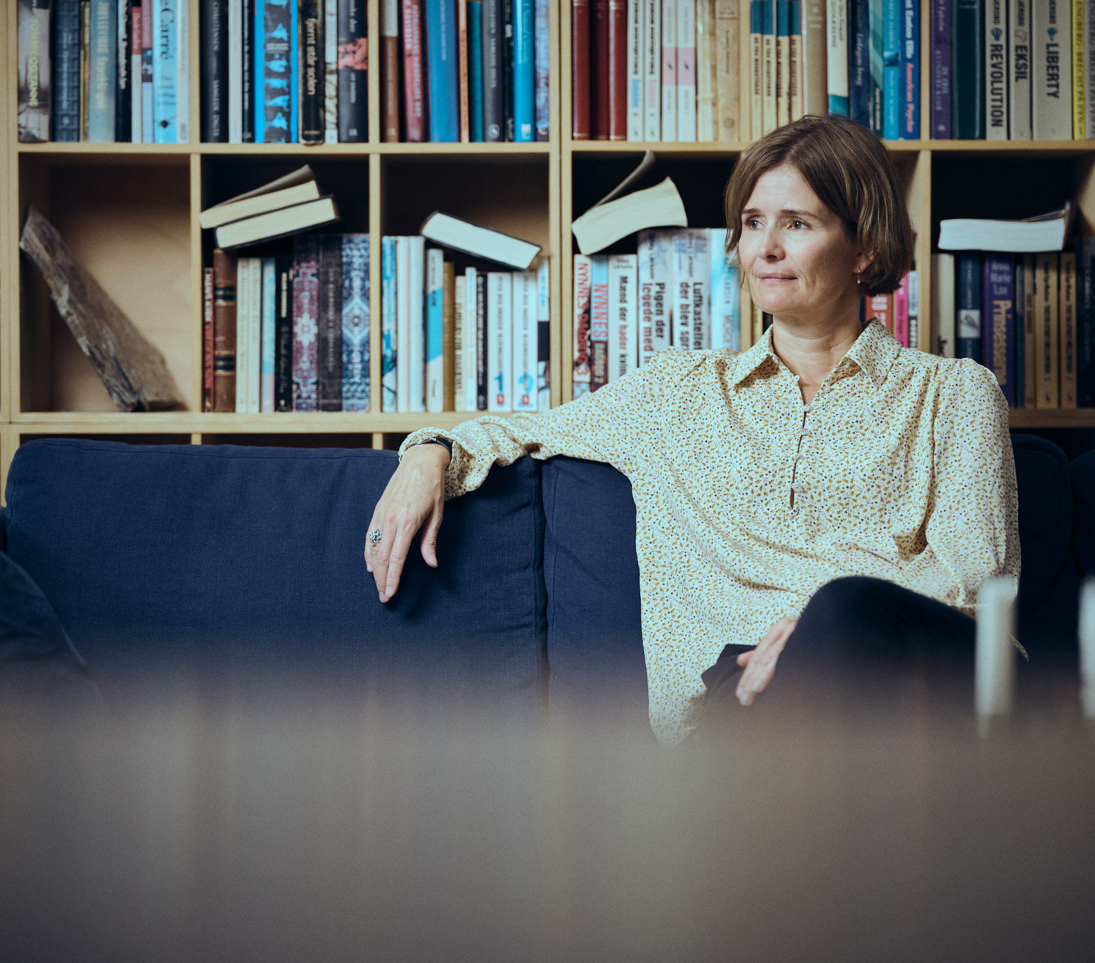

|  |  |  |
| --- | --- | --- |
| Annual report 2020/21 **| People** | and social communities across Deloitte. Furthermore, we | Annual report 2020/21 **| People** |
|  |
| want to reflect the society we are part of, which means |
| we work to reach a more balanced composition of people |
| with different ethnic and educational backgrounds, as |
| well as cultural, LGBTQ+ and religious differences. Thus, |
| our efforts to achieve respect and inclusion in Deloitte |
| are aimed at strengthening diversity of thought in our |
| everyday work. We have updated our anti-harassment |
| policy, which was sent to all employees. The policy |
| reflects our commitment to creating a workplace free |
| of harassment, sexism and discrimination, where each |
| person is treated with courtesy, dignity and respect, and |

where there is equal opportunity for all to succeed.   
 We work to nurture our talents by creating an equal

|  |  |  |
| --- | --- | --- |
|  | Additionally, we teamed up with Lederne - The Danish | playing field where diversity is embraced, and everyone |
| |  | | --- | | **People** | | Association of Managers and Executives - on their | feels included - regardless of gender, race, religion |
|  |  |
| Making room for **diversity** of all kinds | #MeToo campaign during the autumn of 2020 by signing | or background. If we fail to build a more diverse |
| their ‘zero tolerance for sexual harassment’ pledge to | workforce, it will pose a risk to our future business. |
| express our commitment to changing the culture that | Not only will we lose out on a great amount of talent |
| has allowed harassment to take place in Denmark for | and innovation skills and be unable to meet our clients’ |
| many years. We have also taken steps to strengthen our | expectations nor mirror their workforce. Research also |
| commitment towards the inclusion of ethnic minorities | shows that more diverse management teams equate to |
| and international talents. The latter was a result of an | better decision making. Achieving diversity of thought is |
| employee’s courage to share personal experience with | therefore one of our three key strategic choices. |

discrimination and racially motivated harassment on

|  |  |  |  |  |  |  |  |  |  |  |  |  |
| --- | --- | --- | --- | --- | --- | --- | --- | --- | --- | --- | --- | --- |
|  | **Our people and their wellbeing are at the heart and mind of who we are, and** | | the streets of Copenhagen. These stories sparked the | | While diversity comes in many shapes, a better gender | | | | | | |  |
| work on improving the overall employee experience for | | balance is our primary focus. When it comes to junior | | | | | | |
| international talents and ethnic minorities in Deloitte. | | levels, we have a more equal gender distribution with | | | | | | |
| We facilitated workshops on the topics onboarding and | | 40 per cent women in total and 48 per cent amongst | | | | | | |
| integrating internationals as well as including ethnic | | new hires in FY21. However, we still have room for | | | | | | |
| minorities, where the international community in | | improvement if we look at more senior levels, where | | | | | | |
| Deloitte played an invaluable part. On ethnic minorities, | | 34 per cent are women. Among the new senior hires in | | | | | | |
| **what we can achieve together. Looking back on the last year, COVID-19 stands** | |
| we are teaming up with NGOs within the field and are | | FY21, we have 41 per cent women. | | | | | | |
| **out by bringing unprecedented changes to our people.** | |
| planning to launch further initiatives this coming year. | |
| **A** their utmost for our clients, each other and our society. forward, we are truly proud to see more than  2,800 Deloitte employees every day doing s we – cautiously yet optimistically – move | **The past year, we have continued to work with our three strategic focus areas for the talent agenda:**  • **Respect and inclusion** | Therefore, we have spent the past years working | | | | | | |
| **Building a diverse workforce** | |
| intensely on implementing structured and transparent | | | | | | |
| Our people are Deloitte. They are our greatest asset | | processes for recruitment, performance evaluation | | | | | | |
| and making sure our people thrive is a top priority. | | and promotion. These efforts are showing positive | | | | | | |
| Every single day. For our people to succeed and thrive in | • **Leadership** |
|  | their work, we focus on building a culture of respect and inclusion. A culture that reflects our shared values, where | • **Talent attraction and development** | **Women in leadership** | **2016** | **2017** | | **2018** | **2019** | **2020** | **2021** | |  |
|  | people can be themselves without being uncomfortable | | Partner-elected board members | 0% | 0% | 25% | | 0% | 25% | 20% | |  |
| with sharing their background, thoughts or ideas for the | **Respect and Inclusion** |
|  | Management team (Executive) | 10% | 10% | 20% | | 20% | 20% | 10% | **\*** |  |
| future. To unleash the potential of each talent on our | In Deloitte, we strive to achieve diversity of thought. We |
|  | team, we work hard to eliminate biases and change our | believe that diverse groups deliver stronger and more | Partners | 8.6% | 8.4% | 9.5% | | 10.6% | 12.1% | 13% | |  |
| processes to foster a more diverse workforce. This is | innovative solutions to our clients. We want all talents to |
| 8 | Senior Managers and Directors | 29.1% | 32.8% | 30.8% | | 31.7% | 31.8% | 34% | | 9 |
| crucial to secure our future relevance and success. | feel welcome, appreciated and included in our professional |

|  |  |
| --- | --- |
| Annual report 2020/21 **| People** | Annual report 2020/21 **| People** |
|  | |

|  |  |
| --- | --- |
| |  | | --- | | **Future of Work** | |

|  |
| --- |
| **COVID-19 accelerated a transformation towards increased remote working and** |

**new ways of working came to life between not only Deloitte member firms but**   
**also in collaboration with clients, making sure we created the best possible**   
**framework for our people and client projects to thrive in a new normal. The**

|  |  |  |
| --- | --- | --- |
| **flexibility taught us a new way of balancing our careers and daily lives following** | faster in the right direction, we are also empowering |  |
| **the pandemic - that distance is not always a barrier to great collaboration and** |
| **that agile co-creation is as valuable as ever.** | female talents through network-building and working |
| with a more equal gender balance in the succession |
| **The shift into working remotely challenged our culture and well-being, demanding** | planning of commercial leadership roles. Our internal |
| mentoring among talented women helps upcoming |
| **an increased focus on both leadership, motivation and stress to reduce the risk to** | partners learn what being a partner really means and |
| if it is something they want to pursue. This initiative has |
| **our people and our business. We embarked on a journey to develop a new approach** |
| come off to a good start in the past year and will be |
| **to our work, where health and well-being are at the heart of what we do – an** |
| scaled up over the next year. |
| **approach necessary in a global pandemic to minimise the risks of ill-health and** | **Leadership** |
| **the potential loss of talent, but also an approach that emphasises the strong link** |
| At our Leadership Academy, our leaders have built |
| **between our well-being, leadership, organisational performance and the ability** |
| new capabilities and developed their leadership skills. |
| **to strengthen and grow client relations.** | We particularly train our leaders in providing feedback |
| and ongoing coaching in line with our performance |

management approach. Leaders are also trained to

|  |  |  |  |  |  |
| --- | --- | --- | --- | --- | --- |
| 10 | results already. We see that structured processes and | is now back at 20. Our two employee-elected board | be inclusive by enabling them to be aware of personal | One initiative worth highlighting is our Female | 11 |
| biases as well as be more curious and open towards | Academy – a programme that aims to spark an early |
| new perspectives. This year, we piloted a new course | interest in a long-term career at Deloitte amongst |
| in unconscious bias to help our leaders spot their own | female students. Over the past year, the initiative |
| biases and act with courage to address them. This is | has grown and is now driven by a dedicated group |
| all part of our individual and strength-based approach | of young female employees across our five business |
| more objective criteria for promotions provide better | members are women as well. The Board is also | to performance management, which is designed to | units. This has given the programme an even stronger |
| dialogues around talent and potential, which has | more diverse in terms of professional backgrounds, | strengthen our managers’ skills. | platform and enabled the participants to engage in |
| increased both the share of female promotions to senior | geography and international experience, to ensure we |  | a network of talented peers at an early stage in their |
| levels and the number of experienced women hired. As | reflect a global view. As determined by the Danish Act | careers - read more here. Initiatives like this enable |
| a result of many years’ efforts, the number of women | on Approved Auditors and Audit Firms, the majority of | us to link our talents’ visions for Deloitte with how we |
| at the senior manager and director level has increased | the board members are certified public auditors. | attract and retain a diverse workforce. |
| from 31.8 per cent last year to 34 per cent this year. | At the partner level, 13 per cent are female, up from | Our efforts to attract the most talented and diverse |
| In addition, we have joined The Confederation of Danish | 12.1 per cent last year. This is not an acceptable level. | profiles have been rewarded again this year, as |
| Industries’ Gender Diversity Pledge and thus committed | But with 40 per cent women amongst the most recently | Universum has ranked us the #3 most attractive |
| to ensuring that the Danish business community will | appointed partners we are seeing progress in | employer among 3,700 business students. This year, |
| jointly reach the target of a 40/60 gender distribution | the talent pipeline and our initiatives are working, but | In the latest Upward Feedback survey – where | we are particularly happy to move up the ladder as #4 |
| in management and boards of directors by 2030. | we need to accelerate this. | among female business students, as well as increase |
| Fostering inclusion and embracing diversity holds many | **How will we reach our targets?** | employees can give anonymous feedback to their | our attractiveness among students within IT, natural |
| perspectives. Gender balance is just one piece of the | leaders – the results confirm that we continue to make | sciences and engineering. |
| puzzle. Still, it remains a must-win-battle for Deloitte, and | We continue to have a persistent focus on gender | progress with the 'Inclusive Leadership' score climbing |  |
| we will continue to work on initiatives to close the gap. | balance in all processes and structures. Achieving | from 4.41 to 4.44 out of 5. We are happy to see that our |
| Gradual progress on women in leadership positions | gender balance in senior leadership roles requires | training efforts make a difference and that our leaders |
| is evident at the partner level. Amongst the elected | more than just looking at partner promotions. | are becoming more inclusive. |
| board members, our target is to have at least 25 per | Consequently, we have worked dedicatedly to imple- | Deloitte is our people, and every single talent initiative |
| cent female or male board members. *However, due to | ment structured performance evaluation processes. |
| an organisational change in leadership the percentage | We have also developed a systematic approach to | aims to attract, develop and retain the best talents – |
| of women in the management team went down this | identify, monitor and follow-up on pipelines for the | from offering flexible working conditions to focusing on |
| financial year, but with the recent addition of Mette | promotion of women at all levels. This is done to | well-being and individual career paths. To make sure we |
| Louise Kaagaard as managing partner for our Risk | increase female representation at all levels and inspire | are visible at universities, an internal task force hosts |
| Advisory business as of June 2021, the percentage | a new generation of female business leaders. To move | events, talks and much more. |



Annual report 2020/21 **| People**  Annual report 2020/21 **| People**

|  |
| --- |
| **Female Academy** |

|  |
| --- |
| Inspiring the **female leaders** of the future |

**The group behind Female Academy strives to empower female students to**   
**bring their personal and professional talents into play, both as a team and as**   
**individuals. By providing a creative, inspiring and playful environment, 25 female**   
**students every year get access to a space where self-reflection and development**   
**of capabilities are encouraged, and where they can expand their network with**   
**peers, professionals and leaders. Through this and by introducing them to a wide**   
**array of career paths, Deloitte wants to inspire future female leaders and help**   
**them reach their full potential.**

|  |  |
| --- | --- |
| **T** and as individuals. By providing a creative, inspiring empower female students to bring their personal and professional talents into play, both as a team he group behind Female Academy strives to  and playful environment, 25 female students every year get access to a space where self-reflection and development of capabilities are encouraged, and where they can expand their network with peers, professionals and leaders. Through this and by introducing them to a wide array of career paths, Deloitte wants to inspire future female leaders and help them reach their full potential. | **What is Female Academy’s most impactful**  **results?**  We had the opportunity to introduce partners  from all our business units to this group of young  talents. That has been an incredible experience  for the participants and partners and is a strong  reflection of the managerial support needed to make  progress on a cultural change like this. With our  broad representation, we have been able to welcome  participants from five different Danish universities and  with a range of different educational backgrounds.  Furthermore, 40 per cent of the participants had |

a different nationality than Danish. With Female

|  |  |
| --- | --- |
| The initiative was launched as a centralised Deloitte concept in 2018 as one of our first gender-specific initiatives to attract young talents. This year, the initiative was adopted across all business units in Deloitte, who now all take part in the facilitation of Female Academy – and with great success. Below, Simone Emilie Stieglitz and Alexandra Rosenberg Jørgensen - who are part of the group behind Female Academy - will tell us a bit more about the initiative.  **Why do we need a women-only network?**  Female Academy aims to include women in a  traditionally male-dominated culture and inspire everyone at Deloitte – regardless of their gender – to create inclusive and lasting professional relationships.  The gender balance in Danish professional services | Academy, we are fostering a wonderful, inclusive  environment that these women can be part of for the  rest of their careers.  **What is the future of Female Academy?**  The possibilities of evolving Female Academy are  endless. We believe that the broad network that is  created now cultivates lasting relationships across  our company that will grow and instigate internal  multi-disciplinary collaborations, as well as an external  alumni network that can inspire talented women  across our firm and industry. The programme will  continuously reassess its focus to ensure that it stays  relevant and covers prevailing trends and topics.  Therefore, tech is an area we will dive deeper into  going forward. |

firms – including Deloitte – is not up to par, and the   
progression has been moving at a slow pace. With   
Female Academy we want to change this.

12 13

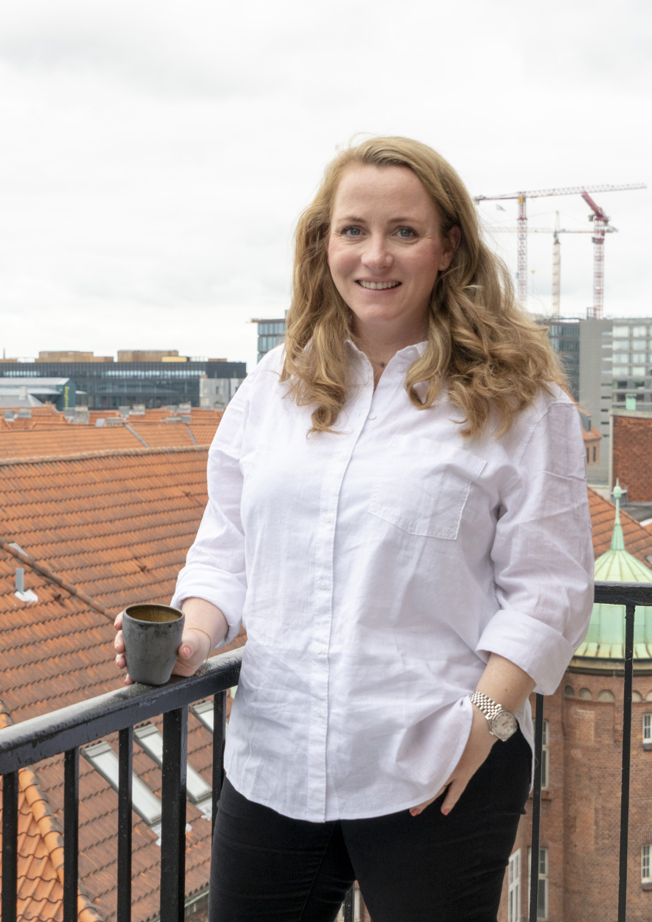

Annual report 2020/21 **| People**  Annual report 2020/21 **| People**

|  |
| --- |
| **Anne Sofie Kann Povelsen** |

A **strong network** will take   
you where you want to go

**Anne Sofie Kann Povelsen is a partner in our Tax & Legal business unit – an area of**   
**expertise she has worked with since 2011. Even though Anne Sofie describes it as quite**   
**a coincidence that she ended up with a career in tax, it becomes clear – when diving**   
**into the story about her career – that creating and maintaining strong professional and**   
**personal networks is at the root of what makes Anne Sofie a strong partner for both**   
**clients and colleagues.**

|  |  |
| --- | --- |
| **W** in 2014. I joined shortly after Niels Josephsen took **your job?**  The feeling of belonging. I came to Deloitte   **hat do you love the most about**  over as the Tax & Legal leader, whom I worked with  previously and who has been a big support in my  career progression. The professional community  that you become part of when joining Deloitte is the  main reason I thrive here. Of course, I am incredibly  proud to represent the biggest professional services  firm, leading within my field worldwide, but what has  kept me motivated and constantly developing is the  strong network of knowledgeable colleagues across  our member firms that Tax & Legal is part of. I went  on maternity leave in May 2020, when the COVID-19  lockdown was still fairly new. Coming back 10 months  later and seeing how the entire team has stuck  together, developed new ways of working and thriving  and simultaneously achieved one of the strongest  results in many years is, to be honest, moving. It  showcases what we are made of and how we stick  together when the going gets rough – that is the  Deloitte I am proud of.  **What achievements are you most proud of?**  Since joining Deloitte, my main focus has been  working together with large Danish companies - both  nationally and internationally - within the areas of  corporate tax, M&A, new market entries, disputes  with tax authorities in other countries, etc. The span  of cultures, countries and types of assignments I get  to work with keeps me highly motivated. It also keeps  me in tune with our own Danish development within  the field, but also to a great extent the development of  other Deloitte member firms and in their countries. | I am particularly proud of our recent work with Chr. Hansen, where we advised them in the process of selling their Natural Colors division - which is active in around 30 countries - to EQT. It was a truly exciting collaboration between three business units: Tax & Legal, Consulting and Financial Advisory, where we worked as one and leveraged our broad expertise across offerings and countries. All our teams worked tirelessly and truly delivered an impact that mattered for the client.  **You became a partner in this financial year. What did that mean to you?**  As a person who always strives for personal and  professional development, the journey towards  becoming a partner has been a natural progression for me. I have always felt very appreciated and  supported by the management, and it felt like the  right timing. When the talk of partnership arose, I  was highly motivated and ready to take that next  step of responsibility. I strongly believe that if you are chosen and pushed forward, you are strong enough to accelerate your career – and urge others to also have faith in themselves and their surroundings. Something I truly appreciated on my journey to the partnership was experiencing how the entire Partner Admission Committee adapted their plans for the admission  process, not only to fit into a sudden lockdown due to COVID-19, but also to take my current life situation into account, as my maternity leave came thrillingly close to the set dates of the partner case presentations. Going that extra mile to make sure I stayed on track of my succession showed me that at Deloitte, we root for each other. Even when the world is quite literally closing down around us, we conquer whatever obstacles we |

are faced with as a team.

14 15

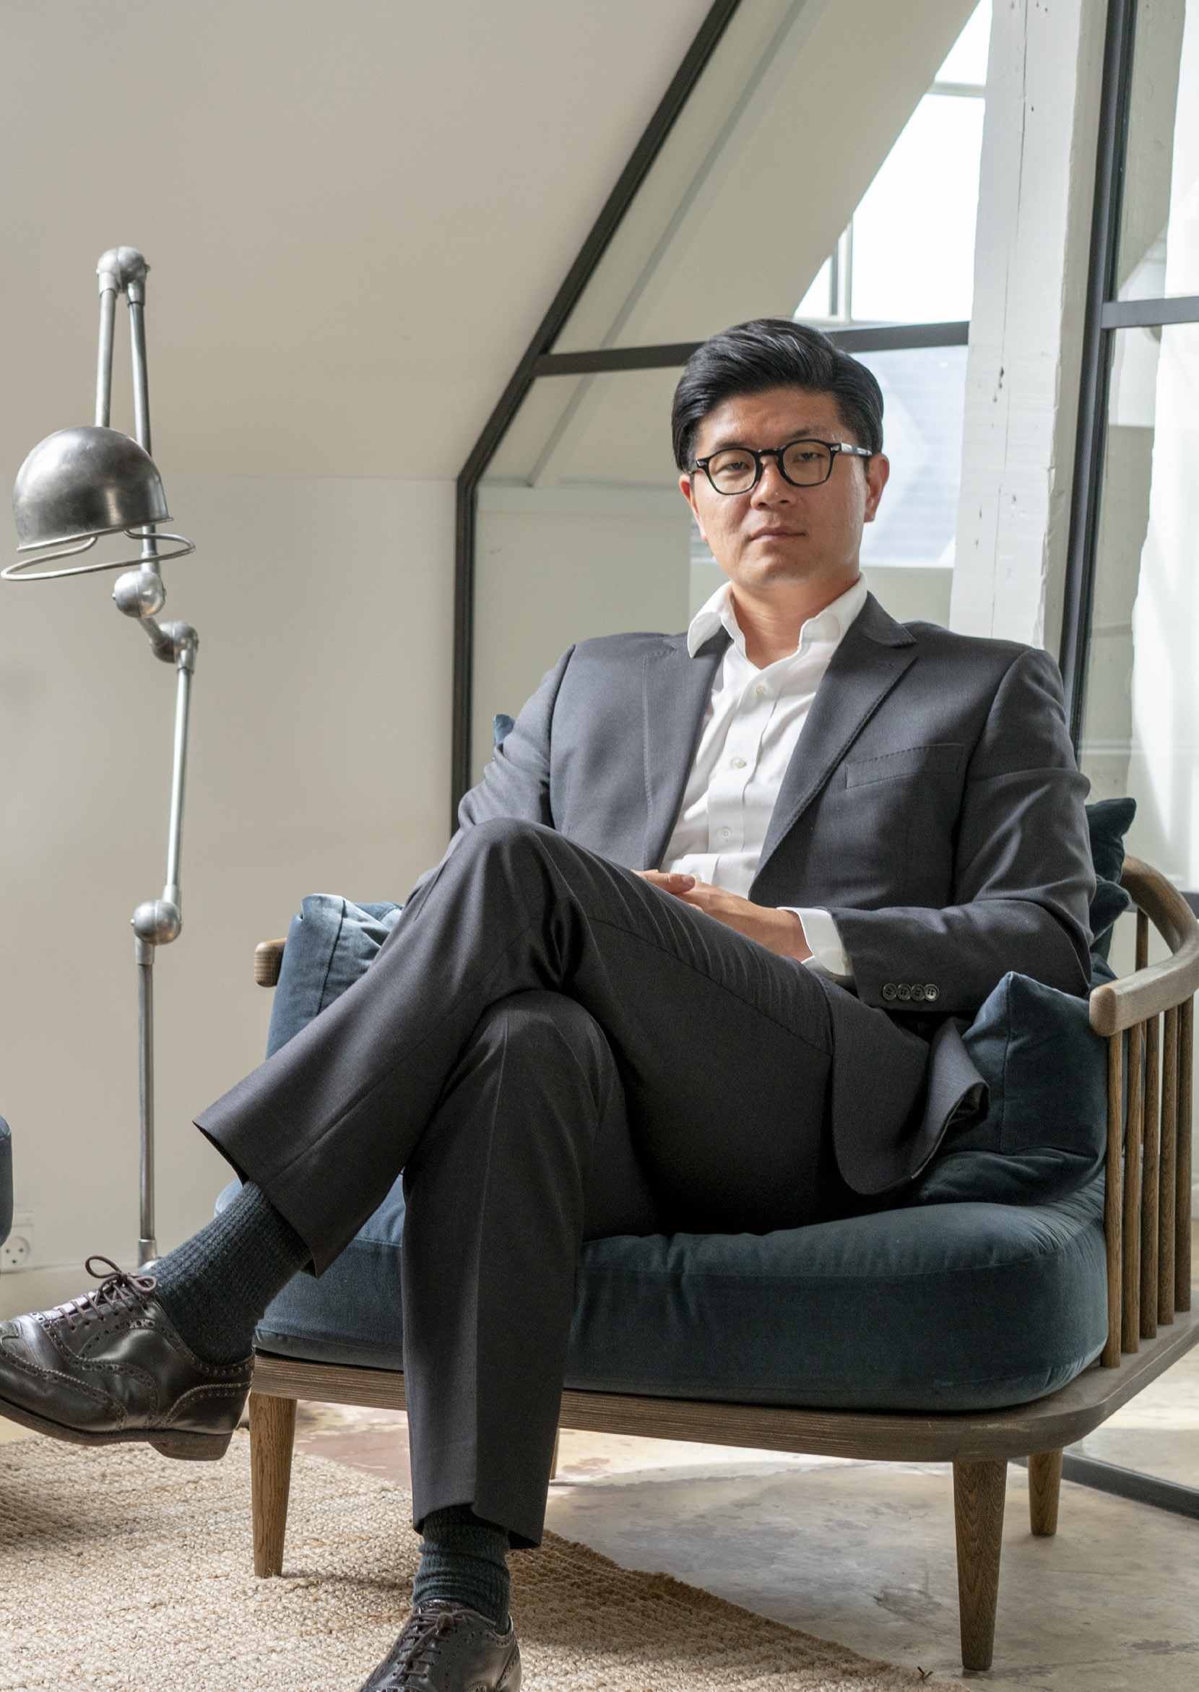

Annual report 2019/20 **| People** Annual report 2019/20 **| People**

|  |
| --- |
| **Jay Choi** |

**Racism does exist**  
– so we need to have those   
hard conversations

**Meet Jay Choi who has worked across the globe before joining Deloitte Denmark,**   
**where he helps to support diversity and inclusion initiatives at the firm – and is**   
**driving our cyber business.**

|  |  |  |
| --- | --- | --- |
| **J** | ay Choi is a partner in Risk Advisory who decided to join Deloitte because of our unique position in the market as a trusted advisor capable of offering an extensive security portfolio that | **How can we move forward on this agenda?**  We have established a good starting point by creating  a greater focus on our international colleagues and  by partnering up with non-profit organisations that  will serve as a sounding board on our respect and  inclusion projects going forward. I believe these  initiatives will help to further integrate, attract and  retain global talents. Having a diverse workforce is  good for business as diversity of thought is becoming  more important than ever before. These initiatives  will help to further build a respectful and inclusive  culture in Deloitte. Caring for each other, supporting  integration and being welcoming towards people from  other countries and cultures as an employer - and as  colleagues - are critical in a globalised world where  many people move for the purpose of work.  **What do you love the most about your job?**  My job is truly varied. I have a healthy balance of  meeting inspiring clients and solving the most  complex problems together with the team. I also  get to work with talents on career and personal  development. Secondly, I love Deloitte’s ambition:  to be bold and always challenge each other in teams  where we have the skills to make a real impact for  clients – and each other. |
| underpins our clients’ digital transformation. Jay is part of an international team that continues to grow and attract talents. However, Jay has not always  felt welcome in Denmark. He decided to share his story to create an open forum to discuss racism and how to improve inclusion. On top of this, Jay’s story inspired our work on improving the overall employee experience for international talents in Deloitte  Denmark.  **This year, you publicly shared your experiences with racism in Denmark.**  **How has the response been?**  Overall, the response has been positive and my  discussion with our CEO Anders Dons in an internal broadcast was an open, safe and candid environment to share my personal experiences. It created a positive focus on inclusion, but also made it clear that racism is a subject of taboo for many Danes, who are sometimes unsure how to approach it. There are different  reasons behind this: awkwardness in sharing such private stories may be one aspect, but I also sense | |

that Danes may view the conversation around racism   
as an ‘infringement’ on other people’s very personal In terms of having a more diverse workforce, we   
experiences. Political correctness and professional are slowly getting there. But we cannot rest on our   
‘space’ are important in Denmark, but as the conver- laurels. When I talk to potential candidates, it is clear   
sation started, my Danish colleagues opened up and   
 that our ability to maintain a diverse workforce helps started talking about issues related to racism. attract our future talents. We need to continue our   
 commitment to making everyone feel welcome - it will   
 help us grow in the right direction.

16 17

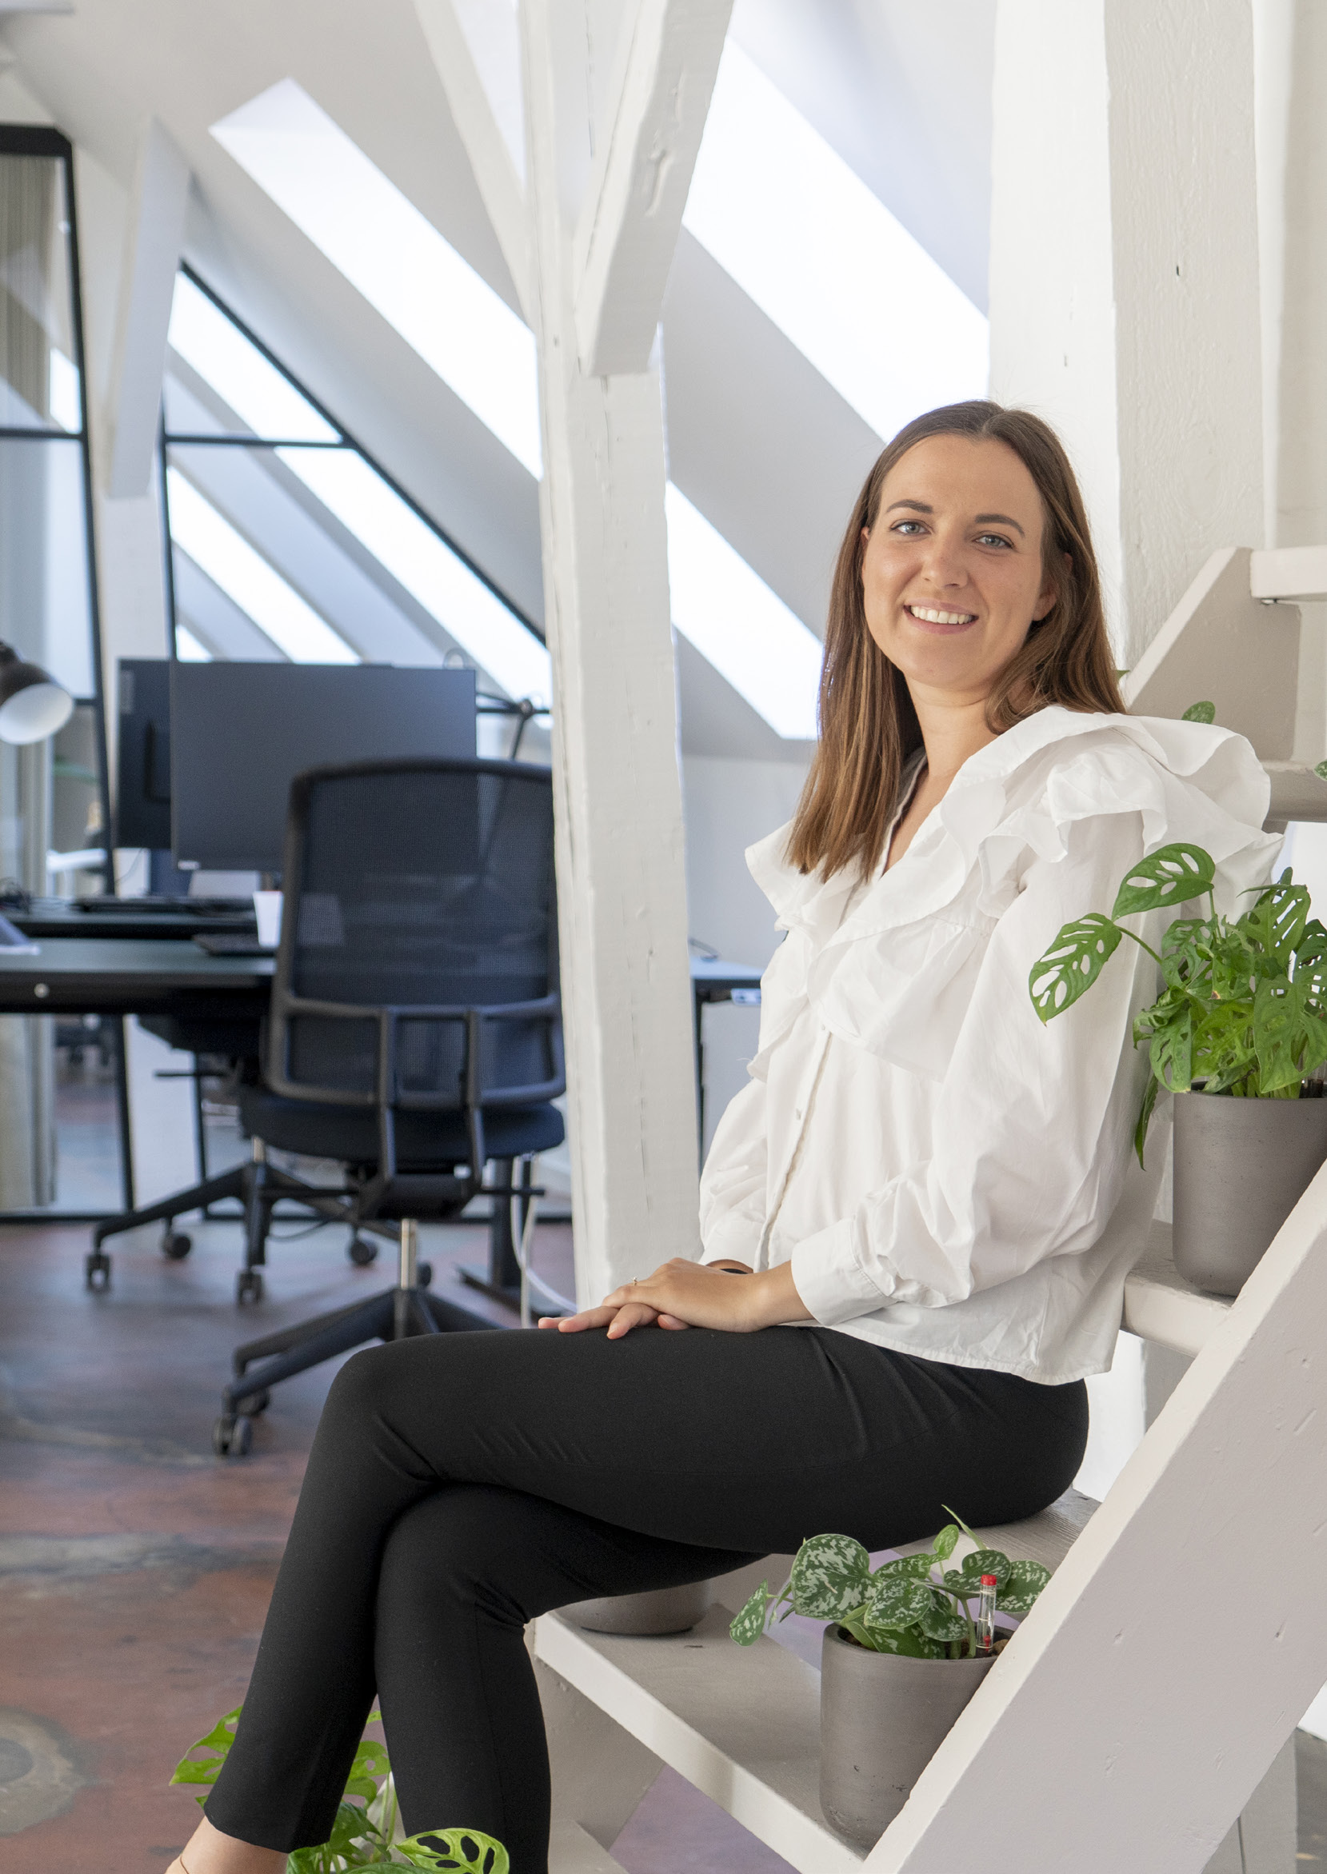

Annual report 2020/21 **| People**  Annual report 2020/21 **| People**

|  |
| --- |
| **Line Egelund Thuesen** |

Moving from **communications**   
**to accounting** – while leveraging   
both skillsets

**Line Egelund Thuesen works as a senior in Audit & Assurance in Kolding, but her Deloitte**

**journey started in Copenhagen five years ago – a journey that came about as somewhat**

**of a coincidence. Before Deloitte, Line pictured herself working in communication.**

|  |  |
| --- | --- |
| **I** communication, she somehow always ended up with pursue a bachelor’s degree in communication. But every time she applied for a student position within   nitially, Line moved from Copenhagen to Aarhus to  a job offer within finance. She took that as a sign and  proclaimed to her family: “I think I’m going to have to be  an accountant”. Looking back, the possibility of being  educated simultaneously with working also appealed  greatly to her, and that is how Line ended up as a  communication trained graduate in Audit & Assurance.  **Success is a journey – not a destination**  I have not always been known for my patience – but  nonetheless, today I am grateful to have ended up in an  organisation like Deloitte that provides an environment  for constant development. By commencing my journey  to become an accountant a bit later in life than most  other graduates, I was introduced to the training from  a different perspective. I knew how to communicate  my dreams and be specific about what motivated me  to be my very best. Whether it has been in terms of my  dreams for personal development, or when I asked to  be transferred from working with small clients to large  clients, I have always felt strong support and have been  shown nothing but support in accommodating my wish  for growth and change. It might not always go as rapidly  as desired – but there are countless possibilities in  Deloitte, and it will happen when you put your best foot  forward. | seen significant changes in how we work. Not only was my profile a bit unconventional when I first started, but I am also part of a generation that more than ever expects training programmes to be customised to the individual and facilitate growth opportunities that fit our personal goals. I truly admire how a large organisation like Deloitte with long-lasting traditions aims to accommodate this, while having a high focus on talent development. It  became particularly clear when I was chosen as one of the winners of the Audit Quality Award last year. After having transitioned to our Kolding office and taken over a large legacy client, I was acknowledged for going above and beyond in my project management of the client and because I succeeded in streamlining the audit. I was lucky to have a partner close to me who could see the results of how I restructured our client work in this case, and how it not only improved the client relationship but also motivated the team that handled the account. It felt like such a personal acknowledgement for both the accountant and the communication specialist in me and made my transition from one office to a new one that much easier. Once again, this emphasised that we are one big team and we lift each other up – not in spite of, but because of our different competencies.  **Next stop: becoming a state-authorised public accountant**  When the COVID-19 pandemic shut down our world at the beginning of 2020, a new adventure began |

for me. In many cases, we went from being a clearly

|  |  |  |  |
| --- | --- | --- | --- |
| 18 | Some have asked if I ever regret spending three | defined finance and accounting partner for our clients | 19 |
| years on a bachelor’s degree in communication, as I | to suddenly being a much wider sounding board. We |
| could otherwise have been three years further in my | were all thrown into a new digital way of working, and |
| career as an accountant. But I don’t see those years | our clients had to rely on us remotely while helping |
| as wasted. Quite the contrary. I see my background in | our clients navigate the Government’s new financial |
| communication as a strength and an enabler to have | support packages, which for many meant either getting |
| gained a strong set of tools within project management | through the pandemic or losing their life's work. I felt |
| and communicating complexity at eye level. I actively use | like we grew ten years in just ten months, and I am |
| my background to reach my goal of becoming a close, | incredibly proud of standing on the other side with a |
| professional sounding board for my clients. | strengthened relationship – not only with my clients but |
| **Talent development in focus** | also with Deloitte, the latter sending me towards my |
| next adventure of becoming a state-authorised public |
| During the five years I have been with Deloitte, I have | accountant, which will start in 2021. |